Assignment – 1

• **Install Power BI Desktop and share the final screenshot of the report view page which appears when power desktop starts.**

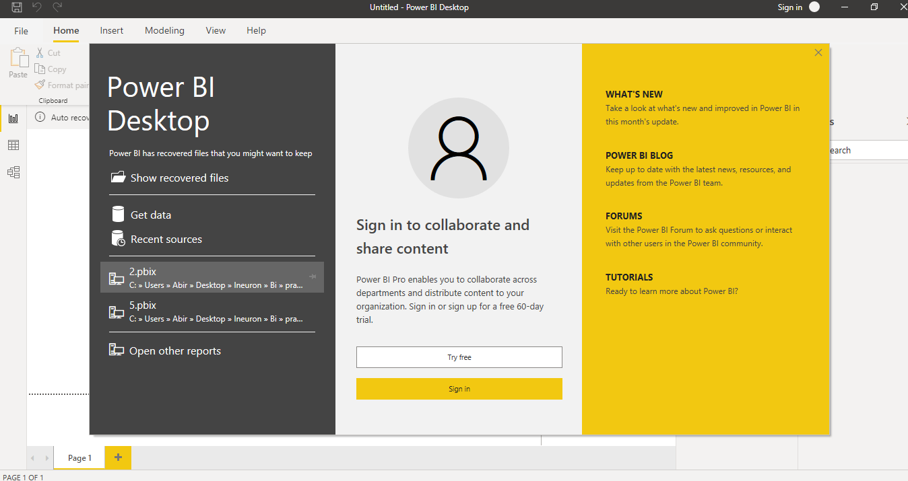

• **Prepare a document and with the following screenshot**-

*Report View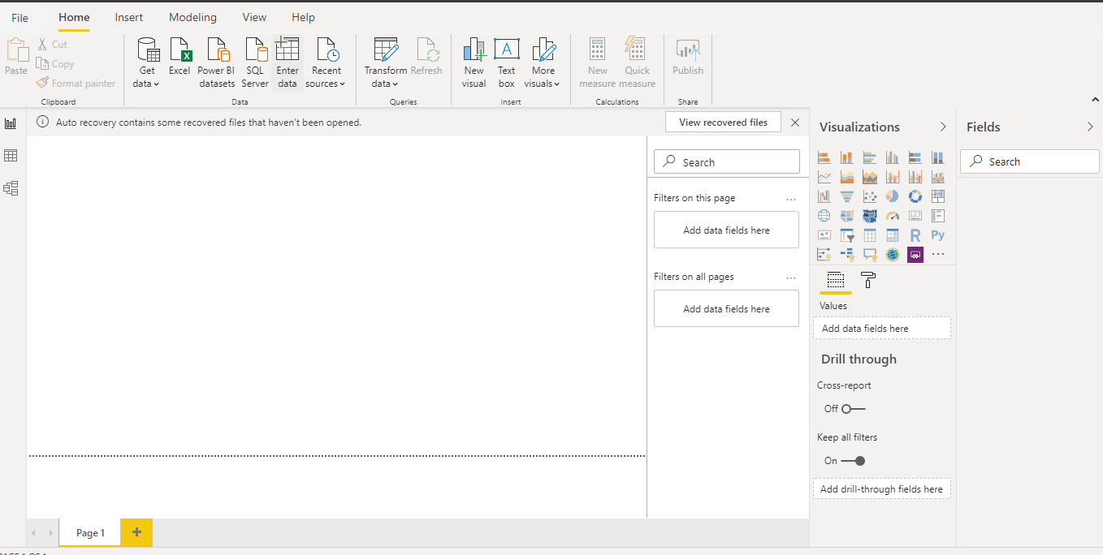*

- *Data View*

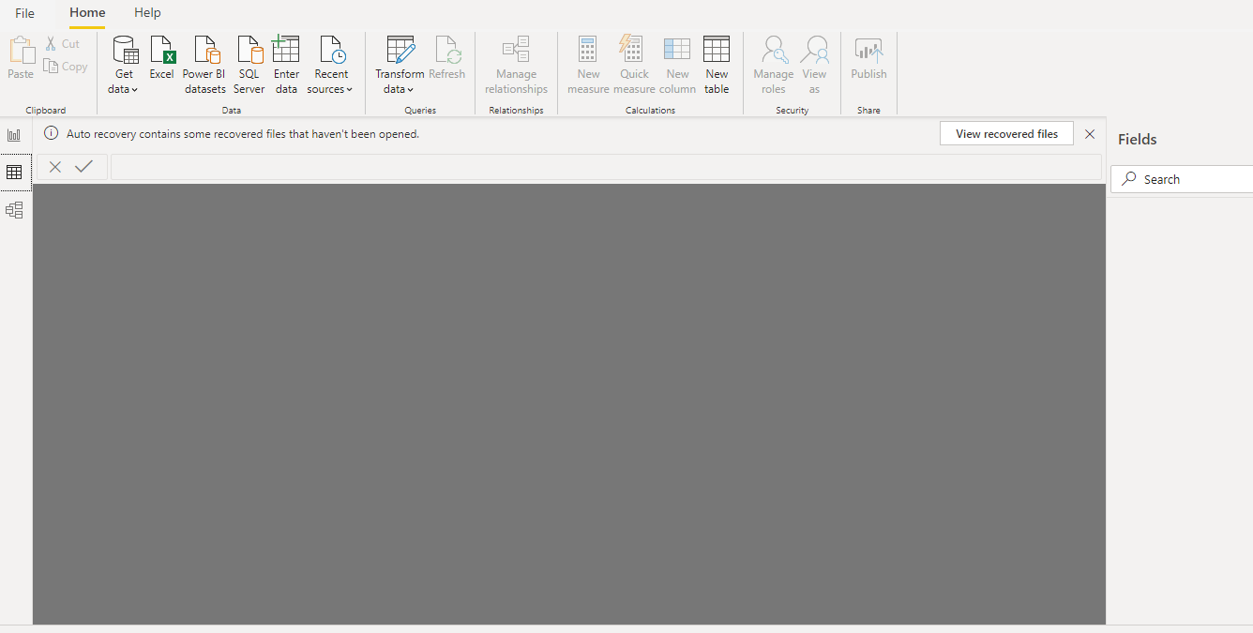

- *Model View*

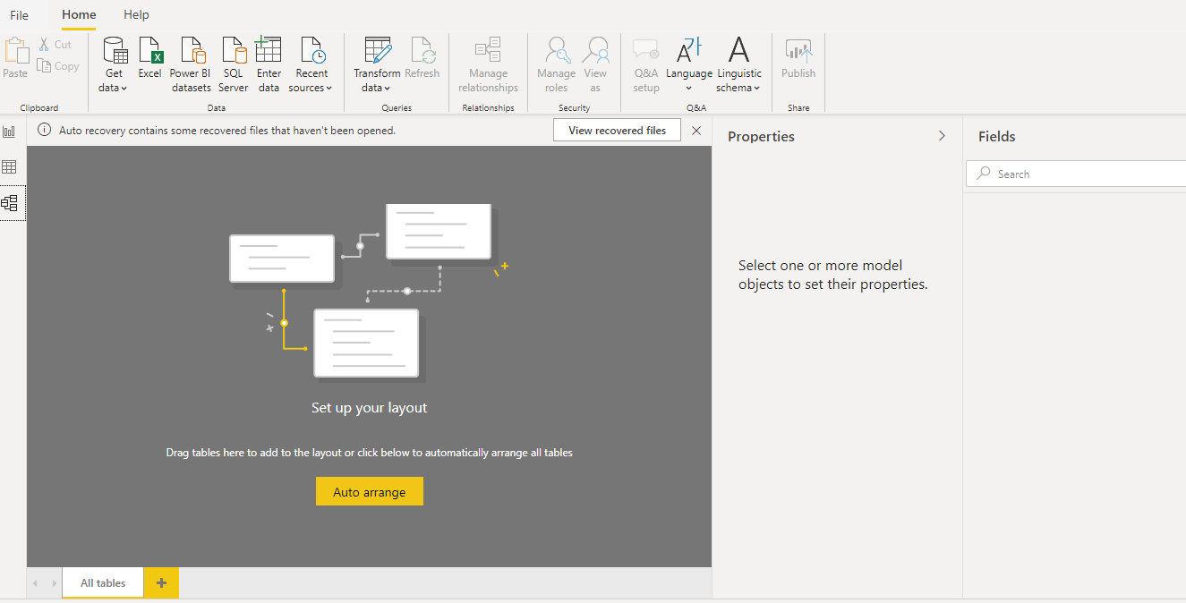

- *Power Query Editor*

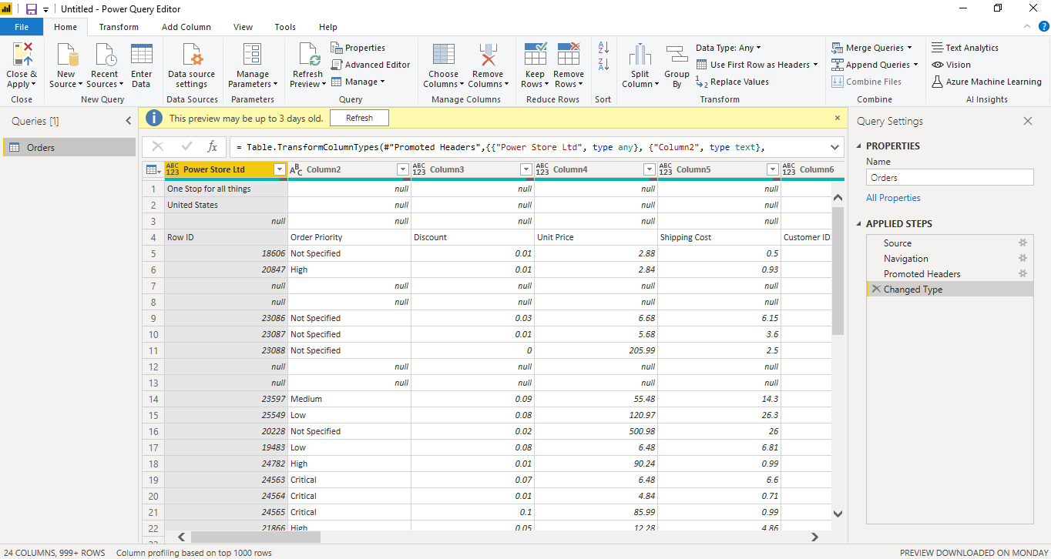- *Advance Editor*

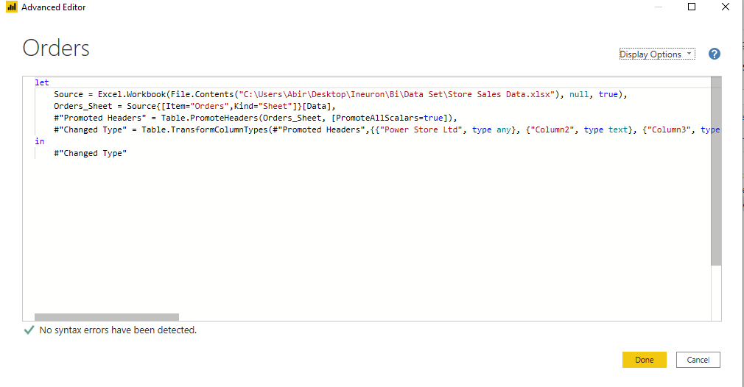

**Power Bi desktop**

Power BI Desktop is a free application you install on your local computer that lets you connect to, transform, and visualize your data. With Power BI Desktop, you can connect to multiple different sources of data, and combine them (often called modeling) into a data model. This data model lets you build visuals, and collections of visuals you can share as reports, with other people inside your organization. Most users who work on business intelligence projects use Power BI Desktop to create reports, and then use the Power BI service to share their reports with others.

This offering is free to any single user and includes data cleaning and preparation, custom visualizations and the ability to publish to the Power BI service.

**Power BI Pro**

Power BI Pro is an individual user license that lets users read and interact with reports and dashboards that others have published to the Power BI service. Users with this license type can share content and collaborate with other Power BI Pro users.

The Pro plan costs $9.99/user/month. It includes data collaboration, data governance, building dashboards with a 360-degree real-time view and the ability to publish reports anywhere. Users can try it a free trial for 60 days before purchasing the subscription.

**Power BI Premium**

Power BI Premium is a great offering. It comes with lower pricing for enterprise scale customers, and with many features such as dedicated server, higher data set size, higher frequency of data refresh, Power BI on-premises and many other options.

The Premium plan starts at $4,995 a month per dedicated cloud compute and storage resource.